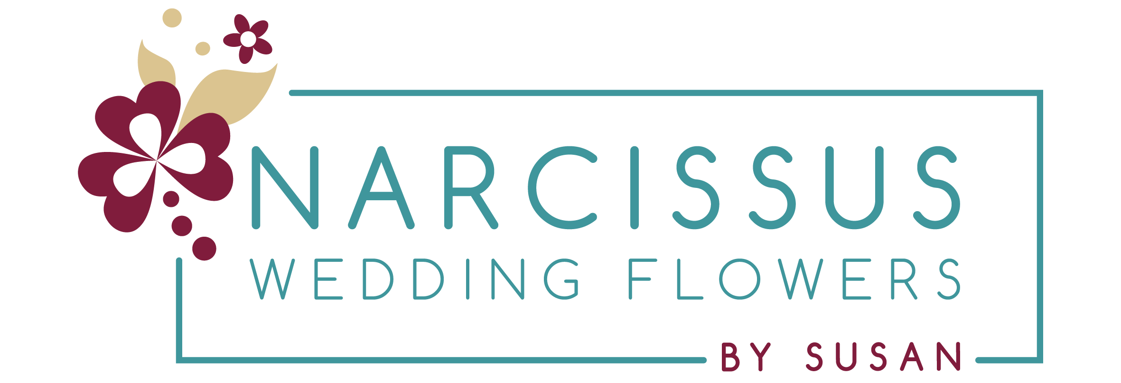

Narcissus Wedding Flowers by Susan – Initial Quote Questionnaire
Not quite ready for a full consultation? No problem!
Please fill out this form and email it to info@weddingflowersbysusan.co.uk. I’ll use your answers to prepare a personalised, itemised initial quote. Don’t worry if you’re not sure about any details yet—just answer what you can!

Wedding Details

- Your full names.:
Answer –

How would you like me to address you both?
I want everyone to feel comfortable and welcome when working with me. If there are particular names, pronouns, words or phrases you’d like me to use (or avoid), please let me know.
Answer –

- Email address(es):
Answer –

- Phone number(s):
Answer -

- Tell me a bit about yourselves:
Answer -

- Wedding date:
Answer -

- Wedding venue(s):
Answer -

- Ceremony time (if known):
Answer -

- Approx. number of guests:
Answer -

- Do you have a floral budget in mind?
Answer -

✨ What’s Your Vibe? (pick as many as you like)
💕 Romantic 🌿 Whimsical🖤 Modern🎉 Maximalist🤍 Minimalist💍 Traditional
🌈 Colourful🌾 Rustic❓ Something Else
Answer -

- Do you have a specific wedding theme or vision?
Answer -

- Do you have a colour scheme?
Answer -

- Any favourite flowers or florals with personal meaning?
Answer -

- Any flowers you don’t like?
Answer –

Wedding Party Flowers
Every wedding is different, and not every wedding has a bride and/or groom. I’ve included a range of options below to help me understand your requirements and provide the most accurate quote and advice. Simply leave blank or delete any options that don’t apply to your wedding.

Bridal Bouquet

- Preferred shape:
Traditional Posy |Asymmetric Tied | Teardrop Cascade | Full Cascade | Something else?
Answer –

- Preferred style:
Loose, natural “just-picked” feel | Neat and well-structured | Flower explosion – bold & mixed blooms | Minimalist – 1-2 flower varieties
Answer –

- Preferred size:
Small but beautiful | Just a few stems | Medium | Big, bold & beautiful
Answer –

- Foliage preference:
No foliage | Just a little for structure | Love foliage with flowers | Mostly foliage with floral accents
Answer -

- Flowers you’d like included:
Answer -

- Anything else I should know?
Answer -

Bridesmaid/attendants
- How many?
Answer -

- Maid/Matron of Honour? Special flowers or size?
Answer -

- Same questions as bridal bouquet (shape, style, size, foliage)?
Answer -

- Smaller versions or unique designs?
Answer -

- Any particular flowers?
Answer -

- Anything else?
Answer -

Children
- How many & what ages?
Answer -

- Preferred flowers or accessories?
Mini bouquets | Wands | Petal baskets | Pomanders | Floral hoops | Flowers for a cuddly toy Buttonhole
Answer -

Buttonholes
- How many & for whom?
Answer -

- All the same or variations (e.g. special one for Groom)?
Answer –

- Preferred style:
Traditional lapel | Pocket square
Answer -

- Size:
Simple | One flower + detail | Mini bouquet-style
Answer -

Ladies’ Corsages
- How many & for whom?
Answer -

- Style:
Wrist | Handbag | Jacket pin
Answer -

- Size preferences?
Answer -

- Should they match the wedding florals or individual outfits?
Answer -

Ceremony Flowers
- Are the ceremony & reception in the same venue?
Answer -

- Is there a turnaround between events?
Answer -

- Flowers for ceremony space?
Arches / Backdrops | Pew ends / Chair posies | Registry table | Welcome signage | Aisle petals | Other
Answer -

🍽️ Reception Flowers
- Top table style:
Long | Round
Answer -
- How many people?
Answer -
- Will there be table linens?
Answer -

- Floral design for top table?
Flowers running the length| Centrepiece only
- Answer -

- Guest tables – How many? Style? If banquet, describe your layout.
Round | Banquet
Answer -

- Floral style for tables:
Simple & minimal | Loose & rustic | Bold flower explosion
Answer -

- Flower height preference:
Low – easy to chat over | High – dramatic but keeps sightlines clear
Answer -

- Anything else?
Answer -

🍰 Cake Flowers
Would you like fresh flowers on the cake?
Answer –
If yes, tell me about your cake -
- Decorate the cake table too?
Answer -

🔖 Signage
- Would you like floral touches on your signage?
Answer -

🎁 Thank You Gifts
- Do you need floral gifts for speeches or special guests?
(e.g. Mothers, friends, helpers)
Answer -

💡 Any Other Floral Ideas?
- Wall installations | Venue-specific arches or doorways | Cars | Pets | Memory tables | Guest book area | Other ideas
Answer -

📸 Visuals
If you have any inspiration—photos, screenshots, mood boards, or Pinterest links—feel free to attach or link them. The more you share, the more accurate and personalised your quote will be!

Use this space if you would like to share more information or details about your wedding.

Thank you for taking the time to complete our questionnaire.
Please return your completed form to info@weddingflowersbysusan.co.uk and we’ll get your initial quote over to you as soon as possible.

